Racing to English | Initial assessment | Notes

Teachers notes:
There are 40 steps in Racing to English, where should you start with your pupils/students? If they are beginners, that’s an easy question to answer: start with Step 1. But what if they already have some English? Hopefully, this assessment tool will indicate where to start.

READING/WRITING: Learners need to have reading/writing skills to complete this assessment – if they can’t read/write Roman script then it’s helpful to start teaching some of the earliest Racing to English activities.

WHOLE CLASSES: This assessment is most helpful when working with larger groups or whole classes. Print out enough copies for everyone and ask them to complete it.
Make a note of the point when the learners begin to struggle with the questions, that is the approximate stage/step that they should be starting on. I have highlighted the key steps in yellow.
If the students find the assessment easy, then start using Racing to English at Stage 2 Step 20 Guess Which. This is a fun activity, and it will allow you to check that students are as fluent as their assessment results indicate.

STARTING POINT: This assessment will, hopefully give you a starting point, but it cannot be completely accurate. For instance, your students may be excellent at a written task but unable to do the same thing orally. It’s important to be flexible and to swap to a lower or higher step if necessary.

SMALL GROUPS: If you are working with small groups, rather than using this test a good way to find the correct level for learners, which is to use one of your favourite activities from Racing to English and see how they get on with it. I would have half a dozen different activities at different levels ready and so if the first one seemed too easy then move them on to another.
Here is a list of my favourite activities that I might use for assessment.
3g. Face and body photo track
4e. Guess which girl
6h. Actions photo track
9i. Did you track
10c.Angry fell in road (Story)
13m. When do/does track
14h. Animal features
15x. Do/Does/Did track
17a. The learner driver
20a. Guess which person

Racing to English | Initial assessment | Stage 1

STAGE 1 Step 1
What’s your name?
How old are you?
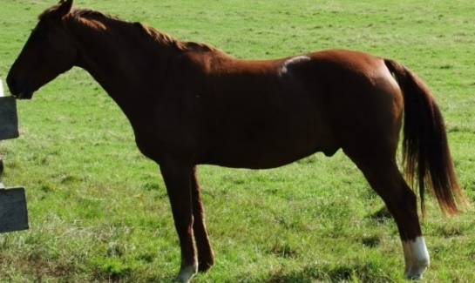 |  | What’s this?

STAGE 1 Step 4
How many eyes have you got? | _____ got _____ _______.
How many toes have you got? | _____ _____ _____ ________.
How many faces have you got? | _____ _____ _____ ________.

STAGE 1 Step 6
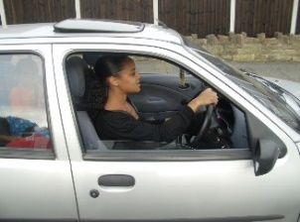 | What’s she doing?
What are you doing? Write 2 things. Write sentences.

What are you wearing? Write 4 sentences.

Racing to English | Initial assessment | Stage 2

STAGE 2 Step 9

Write the correct verb on the line:
My name ______(am/is) Zabida.
One day when I _______ (is/was) a six-year-old
girl, my sister ______ (say/says/said),
“______ (Go/Went) to the shop and
______ (Get/Got) some sweets for me.”
I ______ (went/going/go) to the shop, and
I ______ (get/got/getting) some sweets.
When I ______ (coming/come/came) out of the
shop, I _____ (see/saw/seeing) a dog.

Now write 5 things that you did yesterday:

- Yesterday I ___________________________________________

- _____________________________________________________

- _____________________________________________________

- _____________________________________________________

- _____________________________________________________

Racing to English | Initial assessment | Stage 2

STAGE 2 Step 13
Change these sentences into questions:
She is running. | Is she running?
My friend has got a car.
We see things with our eyes.
I’ve got a phone.
Zabida went to the shop.
She lives in a house
She saw a dog.

Write the correct verb on the line:
Every day I _________________ (go/am going/went/gone) to the shop
Yesterday I _________________ (go/am going/went/gone) to the shop
Today I _________________ (go/am going/went/gone) to the shop

__________________ (Do/Are/Am/Did) you to school yesterday?
__________________ (Do/Are/Am/Did) you go to school every day?
__________________ (Do/Are/Am/Did) you going to school today?

