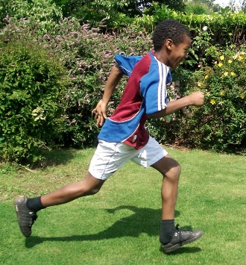 | Racing to English

Stage 1: Beginners
CONTENTS

Step 1:  Naming (singular)  What's this? It's a ... | Step 2:  Naming (plural)  What are these? They are | Step 3:  Face & body  Have you got 3 eyes?
Step 4:  Have/Has got  Has she got a red coat? | Step 5:  Likes, dislikes, & food. Do you like rice? | Step 6:  Actions  She's driving
Step 7:  House/rooms, family (2), in/on/under | step 8:  Vehicles, street, park  & clothes | Maths 1:  Counting, plus/minus  & money
Maths 2:  Time &  lang. of computation | Photo Phonics  Intro to letter sounds

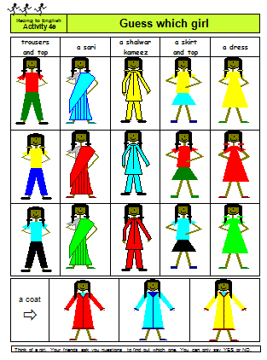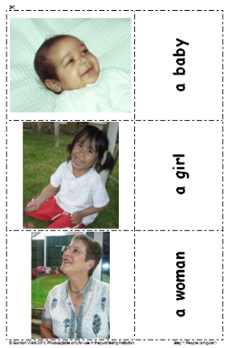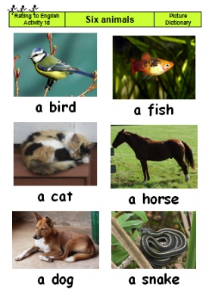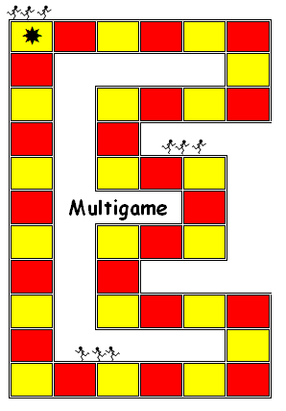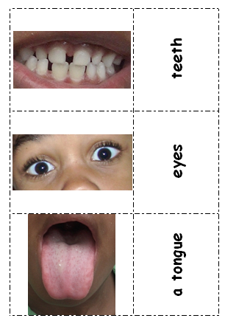

Step  1 | Naming (singular)  What's this? It's a... | Step  1

Language learning focus
Language function | Naming oneself, common objects and basic colours
Sentence structures | - What's your name?  - What's this? It’s a .... Is this a ...?
Vocabulary | - pen, ruler, pencil, felt tip, etc  - girl, boy, man, woman, baby  - dog, cat, bird, fish, horse, snake  - red, yellow, blue, green, black, white

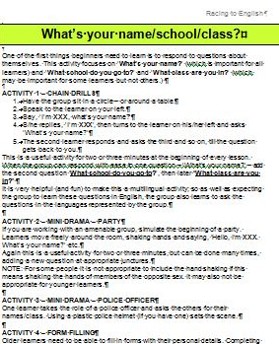  1a. First steps | 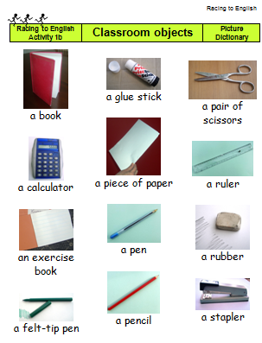  1b. Classroom | 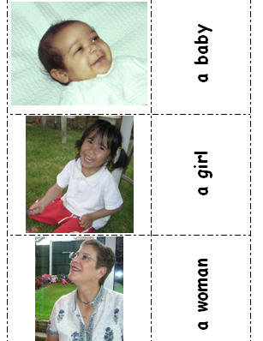  1c. People | 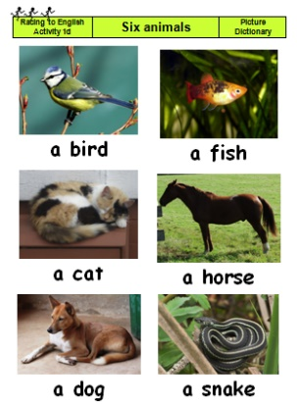  1d. Six animals
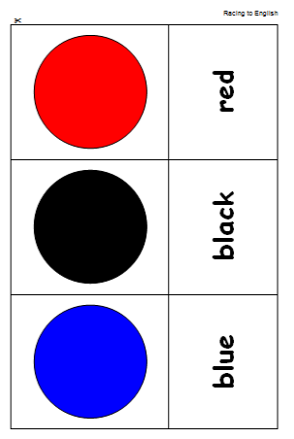  1e. Colour pairs | 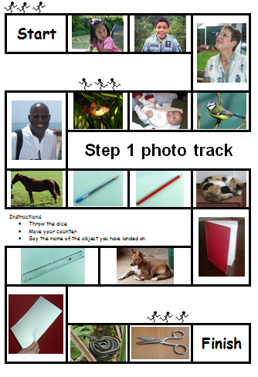  1f. Step 1  photo track | 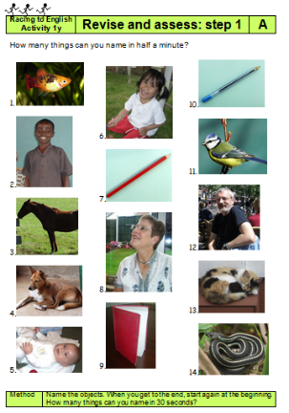  1g. Revise & assess step 1 | 1x. Multigame

Step  2 | Naming (plural)  What are these? They are ... | Step  2

Language learning Focus
Language functions | Sentence structures
Giving personal details | What's your first name/surname?
Naming objects using the plural form | What are these? They are ...
Asking for things | Please can I have a ...?

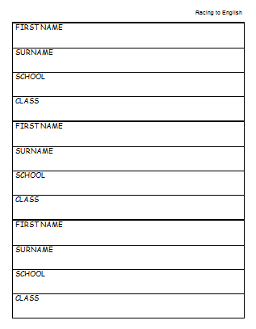  2a. Surname | 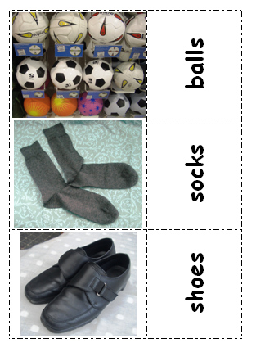  2b. Plurals | 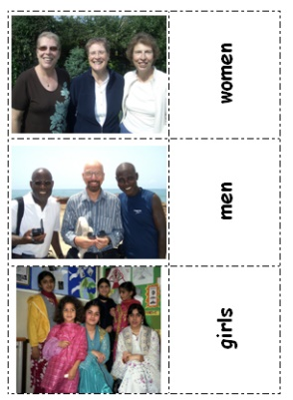  2c. People plural | 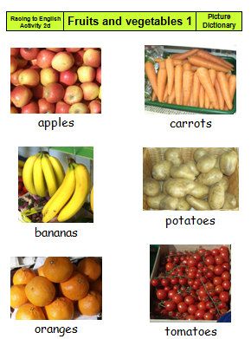  2d. Fruit/veg 1
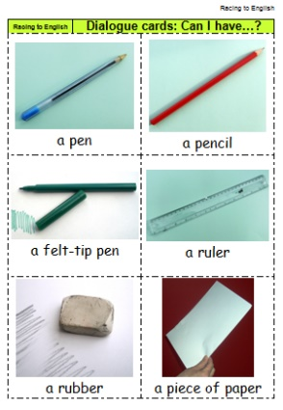  2e. Can I have | 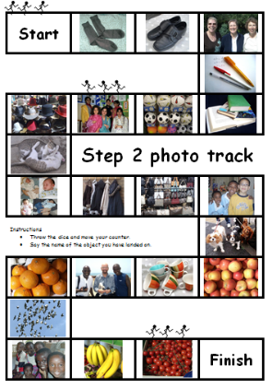  2f. Step 2 photo track (revision) | 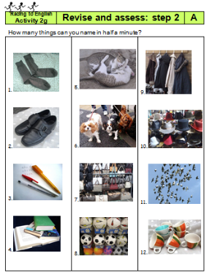  2g. Revise & assess step 2

Step  3 | Face & body  Have you got ...? | Step  3

Language learning focus
Language function | Giving personal details  Naming parts of the body and face  Counting  Claiming possession
Sentence structures | - What's your address?  - What’s this? What are these?  - How many ... can you see?  - Have you got three eyes? He hasn't got a beard.
Vocabulary: body | a body, an arm, an elbow, a hand, fingers, a thumb, a leg, a knee, a foot, two feet, toes, a back
Vocabulary: face | eyes, ears, mouth, nose, face, hair, glasses, hat, beard, etc.

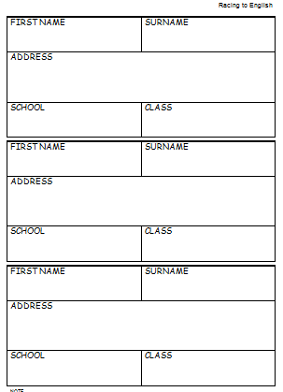  3a. Address | 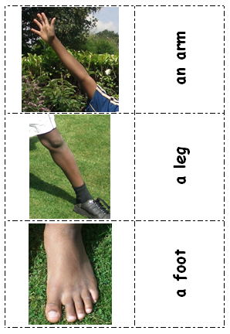  3b. Body photoset | 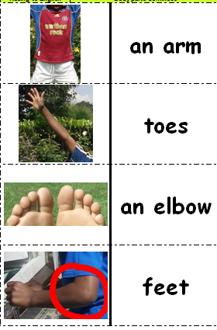  3c. Body dominoes | 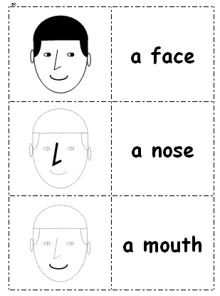  3d. Face pairs
3e. Face photoset | 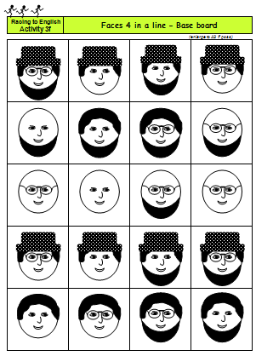  3f. Faces 4 in a line | 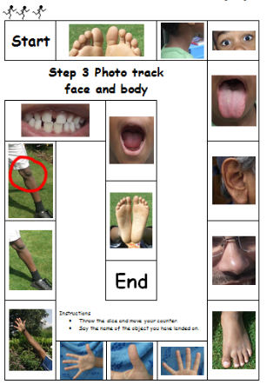  3g. Face & body photo track | 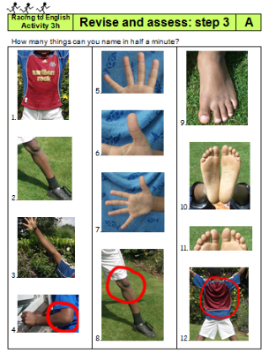  3h. Revise and assess

Step  4 | Have/has got  Has she got a red coat? | Step  4

Language learning focus
Language functions | Sentence structures | Vocabulary
Describing age | - How old are you? | - Age
Naming/introducing family members | - Emily is Arthur's mother. | - Mother, father, brother, sister, etc.
Naming clothes | - What's this?  It's a shirt. | - Coat, jumper, a pair of jeans, a pair of shoes, etc.
Describing colour/ possession | - Has she got a red coat? | - Red, yellow, blue, green, black, white

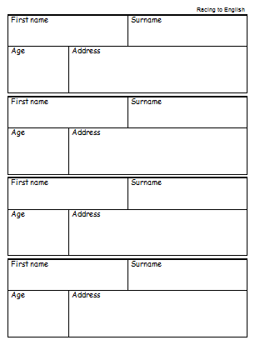  4a. Age | 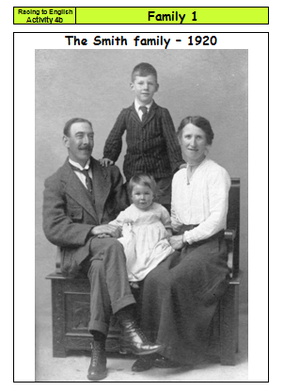  4b. Family 1 | 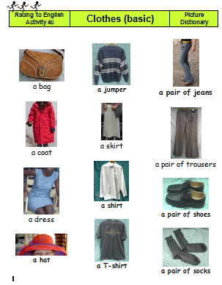  4c. Clothes (1) | 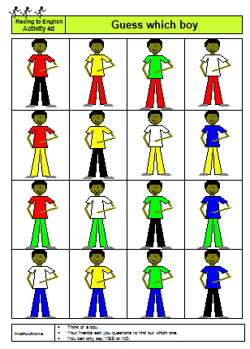  4d. Guess which boy
4e. Guess which girl | 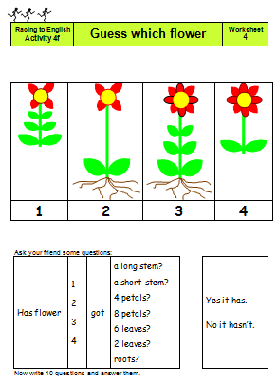  4f. Guess which flower | 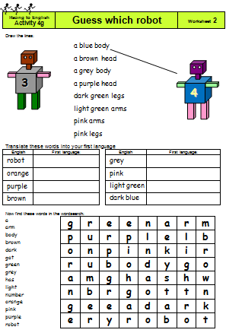  4g. Guess which robot | 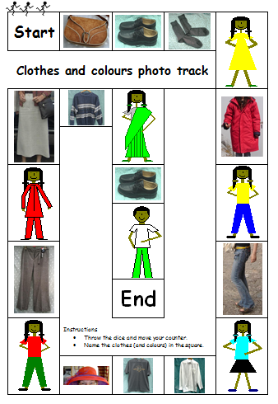  4h. Clothes & colours photo track
Also in step 4:
- Revise and assess step 4

Step  5 | food/likes/ dislikes/  Do you like rice? | Step  5

Language learning focus
Functions | Naming objects; Identifying likes/dislikes; Offering things
Sentence structures | - What’s this? It’s a cup. Is this a plate? Yes it is/No it isn’t.  - What are these? They are apples.  - I like/don’t like ...  - Would you like a ...? or Do you want a ...?
Vocabulary | dining room (table, knife, spoon, plate, cup, etc.)
 | fruit/vegetables/African fruit & veg
 | supermarket (packaging: tins of beans, bags of rice, etc)
 | verbs (like, love, hate,)

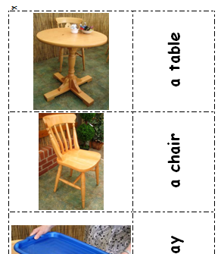  5a. Dining room | 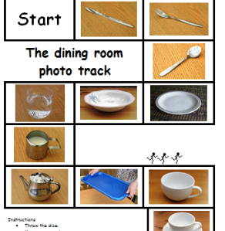  5ax. Dining room photo track |  | 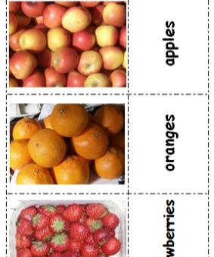  5b. Fruit |  | 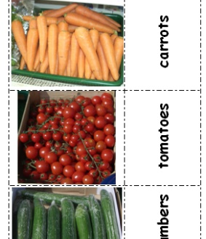  5c. Vegetables
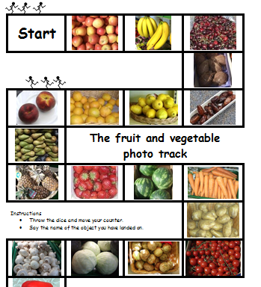  5cx. Fruit & veg photo track | 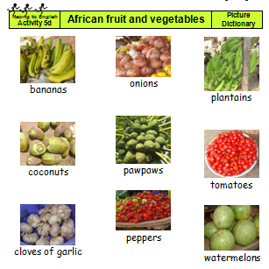  5d. African fruit & veg. |  | 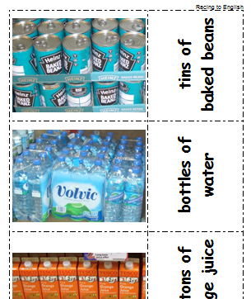  5e. Supermarket |  | 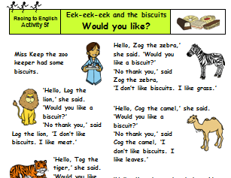  (younger learners)  5f. Would you like  5g. Eek-eek-eek puppets
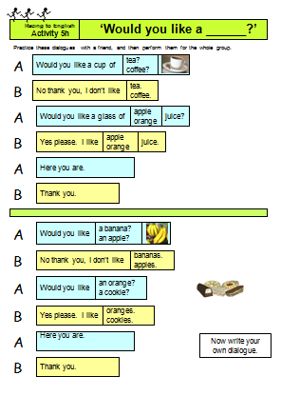  5h Would you like (for older learners) |  | 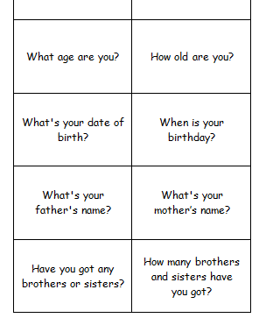  5i. Who are you? |  | 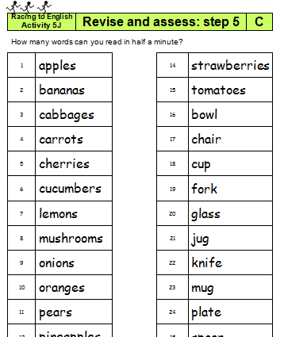  5j. Revise and assess |  | 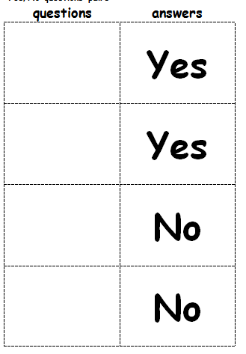  5x “Blank pairs” to make your own pairs activity

Step  6 | Actions  Is she driving a car? | Step  6

Language Learning Focus
Language functions | Naming actions. Talking about ability
Sentence structures | - What’s he/she doing? She’s/He’s XXXing.  - What are you/they doing? I’m XXXing. They are XXXing.  - Is s/he XXXing? Yes s/he is/No he isn’t.  - This is a statue of a man who is holding a sword.  - Can you whistle?
Vocabulary | Common actions e.g.:  drinking, running, writing, drawing, driving a car, eating an apple, riding a motorbike, etc.  Left/right

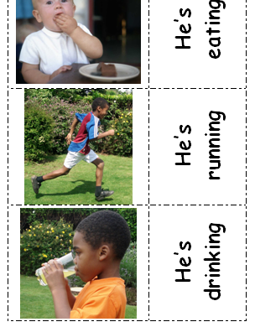  6a. Actions 1 | 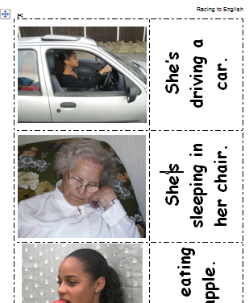  6b. Actions 2 | 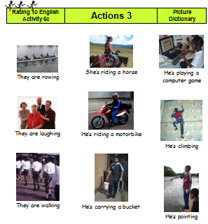  6c. Actions 3
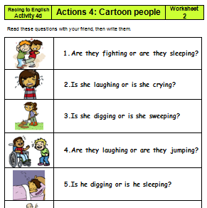  6d. Actions 4 | 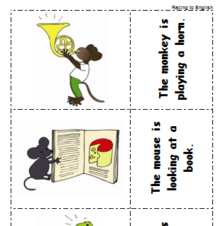  6e. Actions 5 | 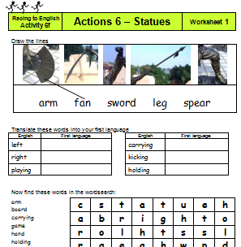  6f. Actions 6
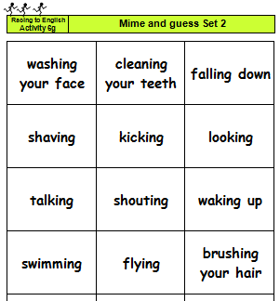  6g. Mime and guess | 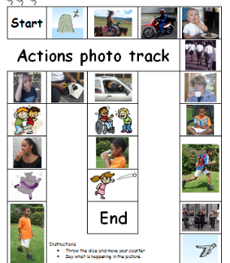  6h. Actions photo track | 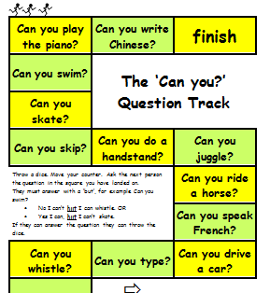  6i. The “Can you?” track
Also in this step:
- 6j. Revise and assess step 6

Step  7 | House and rooms  + possession/family (2)/position (1) | Step  7

Language learning focus
Language functions and sentence structures | Possession  - Is this Fido's mouth? Pat is Emily's granddaughter.  Describing position (prepositions -- in on under)  - The boy is under the table.  - Is there a table in the bedroom?
Vocabulary | - Family members (granddaughter, uncle, cousin, etc)  - House – rooms, furniture and other objects

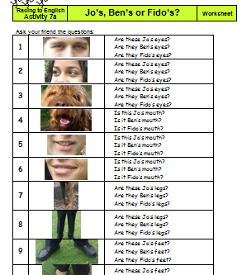  7a. Possession | 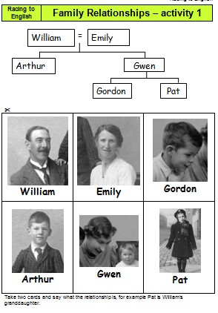  7b. Family (2) | 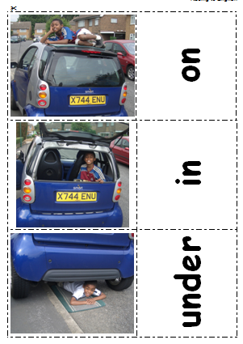  7c. in on under | 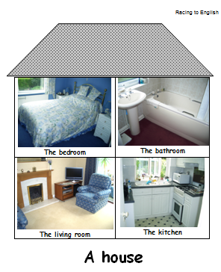  7d. Bedroom
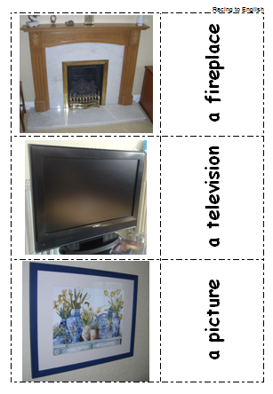  7e. Living/family room | 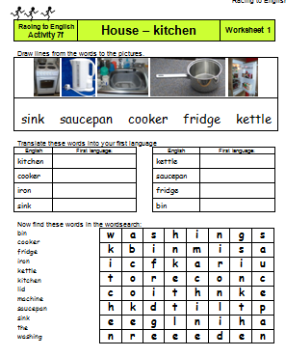  7f. Kitchen | 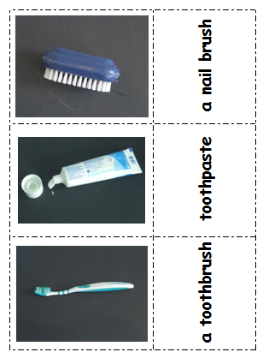  7g. Bathroom | 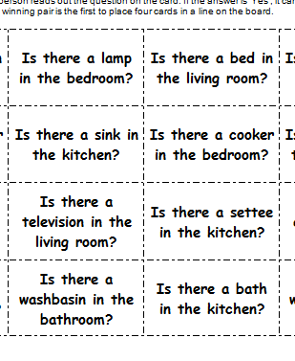  7h. House  4 in a line

Also in this step:
- 7i. Revise and assess step 7
- 7j. House and rooms photo track.
- 7x. Blank 4 in a line

Step  8 | Vehicles, street, park, clothes, etc. | Step  8

Language learning focus
Language functions | Naming objects/Possession/Description (colours)
Sentence structures | - It’s a van.  - Has it got four wheels? Is she wearing a hat?  - Is it blue?
Vocabulary - vehicles | an ambulance, a bike, a bus, a car , a fire engine, etc
Vocabulary - park | a climbing frame, swings, a lake, grass, a slide, etc.
Vocabulary - street | a wall, a tree, a street light, gates, a hedge, etc.
Vocab - men’s clothes | a jacket, a belt, a sweatshirt, a T-shirt, a tie, a shirt, etc
Vocab - women’s clothes | a skirt, a coat, a sari, a dress, a scarf, a pair of jeans, etc

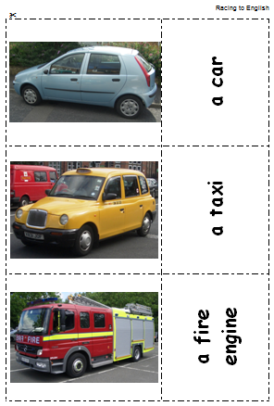  8a. Vehicles | 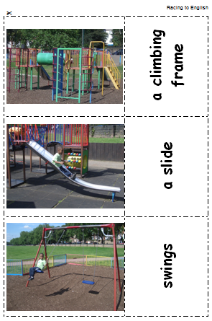  8b. Park | 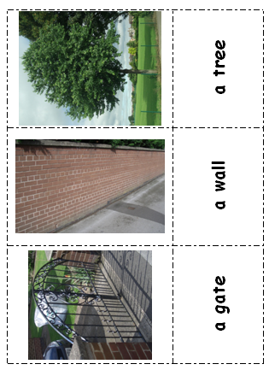  8c. Street | 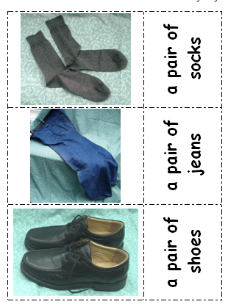  8d. Men’s clothes
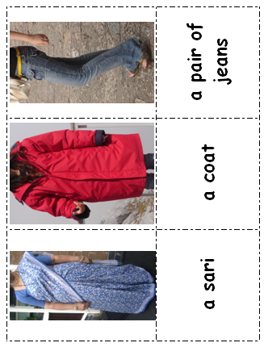  8e. Women’s clothes | 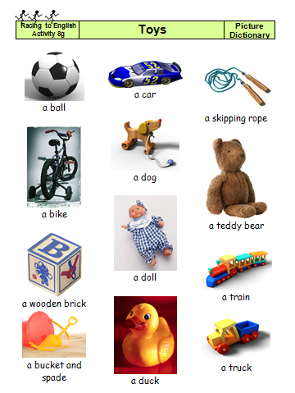  8f. Toys | 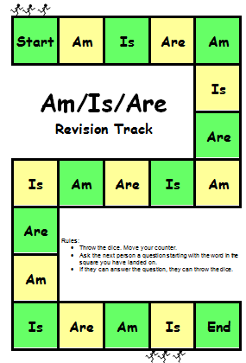  8x. Am/are/is revision track

Step  M1 | Maths 1  counting, addition/subtraction & money | Step  M1

Language learning focus:
Language functions | Counting/Computation/Recognising and talking about money
Sentence structures | How many men can you see? What is 4 add 3? It’s five dollars/pounds
Vocabulary | numbers to 20; add/plus/and; subtract/take away/minus; money
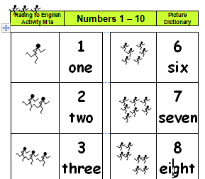  M1a. Counting to 10 |  | 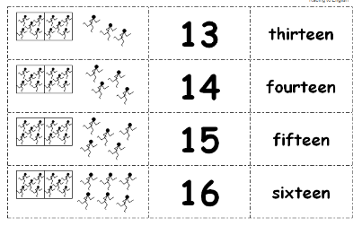  M1b. Counting to 20 | 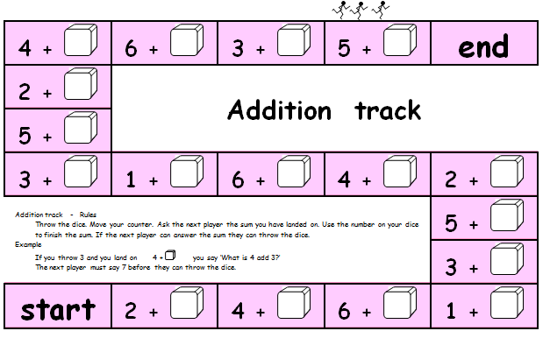  M1c. Addition track
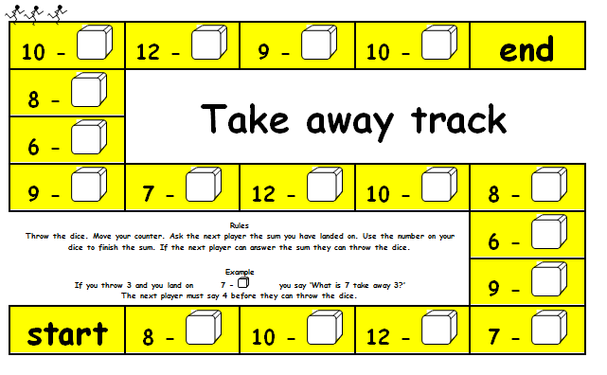  M1d. Take away track |  | 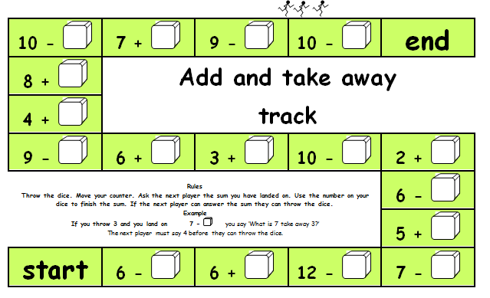  M1d. Add &  take away track | 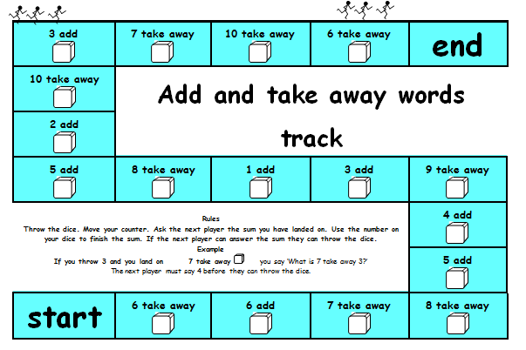  M1f. Add/take words
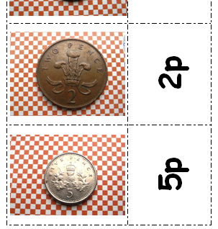  M1g. Money  (UK version) |  | 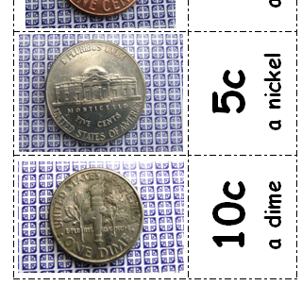  M1g. Money  (USA version) | M1h. Money – how much (max 20p)
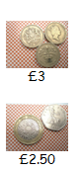  M1i. Money – how much (max £5) |  | 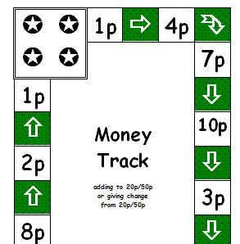  M1j. Money tracks (UK) | 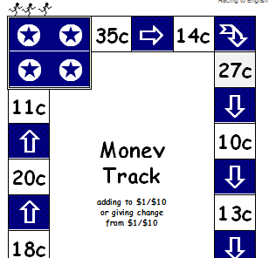  M1j. Money tracks (USA)

Step  M2 | Maths 2 | Step  M2

Language functions | Asking and answering questions about addition, subtraction, multiplication and division.
Sentence structures | - What is 7 plus 4? What is the product of three and nine?  - What time is it? It's ten to five.
Vocabulary | add  plus  and | subtract  take away  minus | more than  less than  difference between | sum of  product  multiplied by

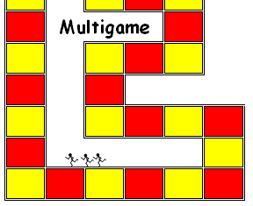  M2a. Numeracy Multigame | 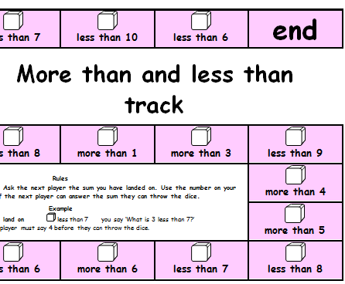  M2b. More than & less than track | 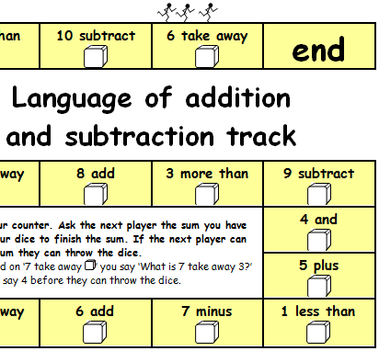  M2c. Language of add/subtract
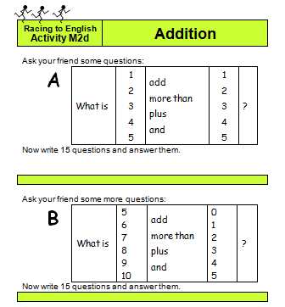  M2d. Addition oral worksheet | 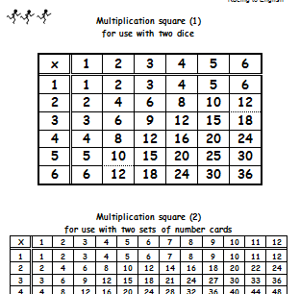  M2e. Multiplying Multigame | 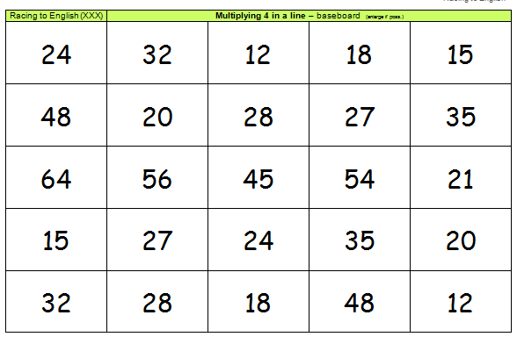  M2f. Multiplying  4 in a line
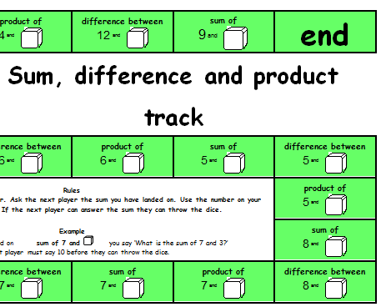  M2g. Sum, product difference track | 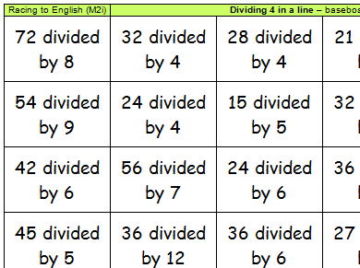  M2h. Dividing  4 in a line

Step  T | Maths  TIME | Step  T

Language learning focus
Language functions | Telling the time
Sentence structures | - What’s the time?  - It’s three forty five (3.45).  - It’s 7 o’clock.  - It’s quarter to/past nine.

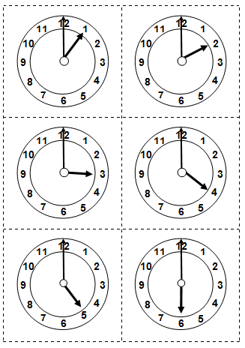  T1: o’clock | 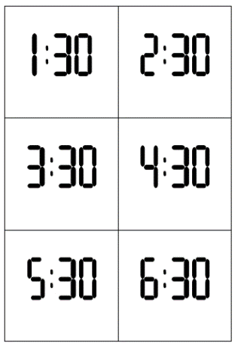  T2: half past | 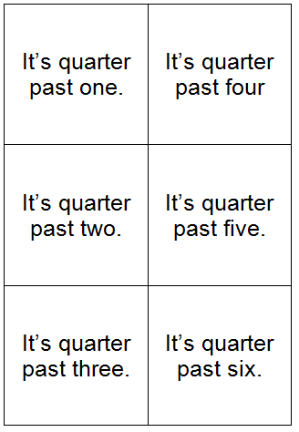  T3: quarter past
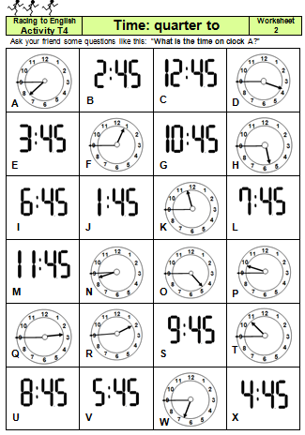  T4: quarter to | 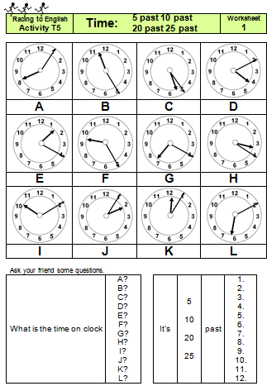  T5: 5 10 20 25 past | 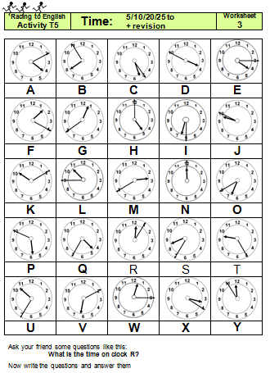  T6: 5 10 20 25 to
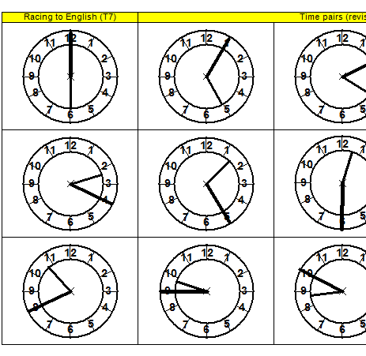  T7 Time pairs – revision | 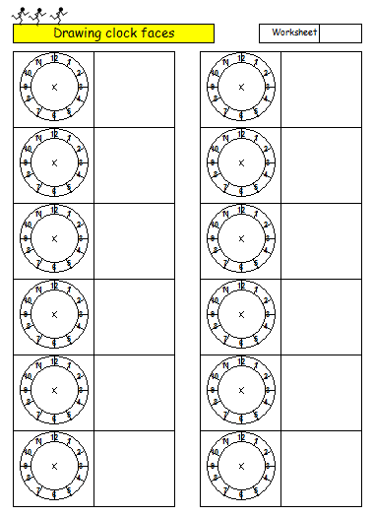  T8: Drawing clock faces

Step  P | Photo phonics  intro to letter sounds | Step  P

Language learning focus:
AIMS | - to ensure that learners can discriminate between the sounds used by English and can pronounce them adequately  - to teach the link between letters and sounds based on vocabulary the learners already know/understand  - to teach and practise handwriting/letter formation.

EXAMPLES:
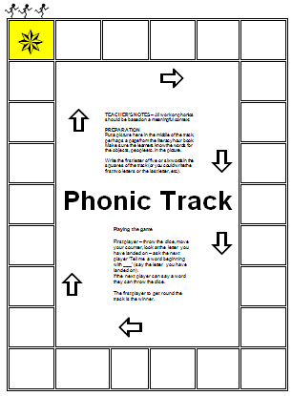  P1. Phonic track | 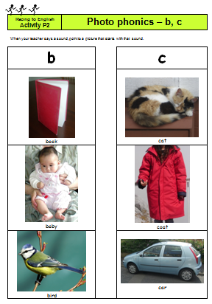  P2: b & c | 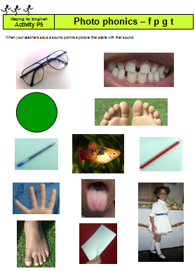  P5: f, p, g, & t
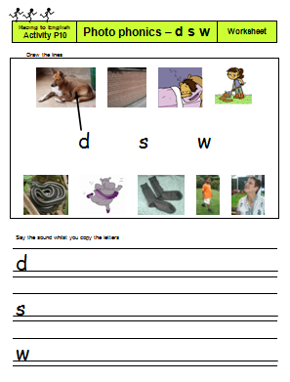  P10: d, s & w | 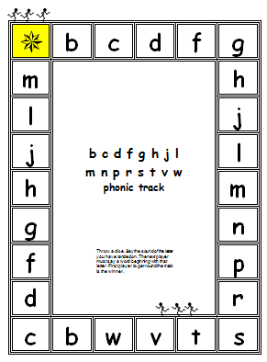  P14. Revision | 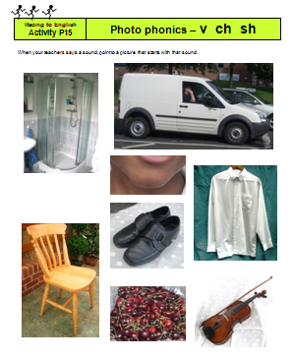  P15. v, ch & sh

As well as the blank phonic track, there are 14 activities in this step. Each one includes  - a picture based activity,  - a phonic track  - a worksheet. |  | Activity | New sounds |  | Activity | New sounds
 |  | P2 | B C |  | P9 | revision
 |  | P3 | H |  | P10 | D S W
 |  | P4 | P G |  | P11 | N
 |  | P5 | F T |  | P12 | revision
 |  | P6 | revision |  | P13 | V
 |  | P7 | R M |  | P14 | revision
 |  | P8 | J L |  | P15 | ch sh

