Racing to English  Activity 5b | Fruit | TEACHERS’ NOTES

This photoset includes:  - A set of photo cards and matching word cards  - A page of the Racing to English Picture Dictionary  - Worksheets for oral and written work | 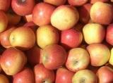
The photos and word cards can be used in many ways e.g.

ACTIVITY 1 – TURN AND ASK
Learners work in pairs and take it in turns to take a picture card and ask their partner “What’s this?” etc.

ACTIVITY 2 – VISIBLE PAIRS (a game for two to four players)
1. Spread out the photo and word cards face down on the table
(NB – For younger children use two sets of the photo cards).
2. Take it in turns to turn over one (Yes ONE) card. Leave the card face up.
3. If any two cards match then the player who has just turned over a card must name the object and can then take those two cards.
4. The player with the most cards at the end is the winner.

WORKSHEETS
Worksheet 1: Copy work: This is some copy work for less literate learners. Ensure that learners can use the vocabulary orally before doing the copying.
Worksheet 2: Translating, matching and wordsearches. This worksheet asks learners to (A) match words and pictures by drawing lines from one to the other,
(B) to translate key vocabulary into their first language and (C) to find some words in a wordsearch.
Worksheets 3/4: Interactive worksheets: These worksheets are based on simple question-based substitution tables e.g.:
Are these | bananas  lemons  pears  coconuts  cherries | yellow?  red?  green?  brown? |  | Yes they are.  No they aren't.

This substitution tables could generate 20 questions. Learners work in pairs to ask each other the questions orally before writing them. This oral work is an essential part of learning a language and completing a worksheet so will not be so effective if this oral work is omitted. I use substitution tables frequently both because they ensure a great deal of repetition and also because they show sentence patterns very clearly.

Racing to English  Activity 5b | Fruit | Picture  Dictionary

apples  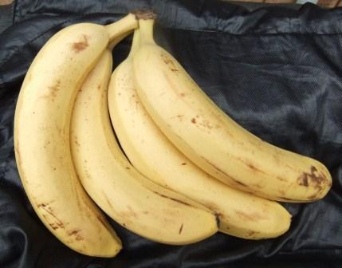  bananas  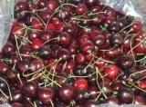  cherries  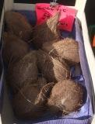  coconuts | 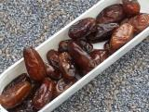  dates  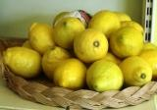  lemons  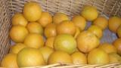  oranges  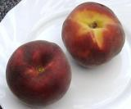  peaches | 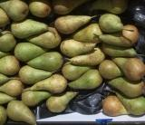  pears  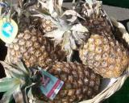  pineapples  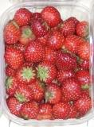  strawberries  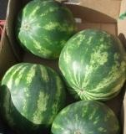  watermelons

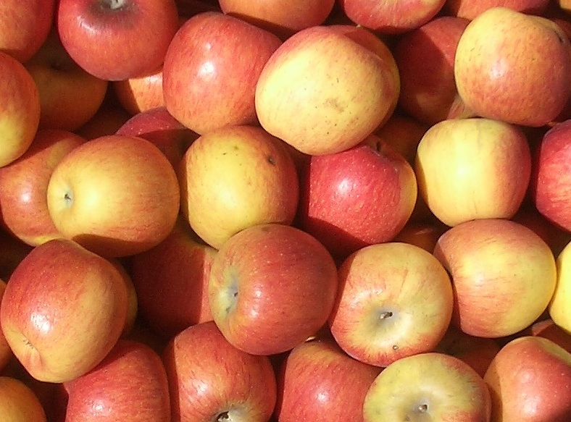 | apples
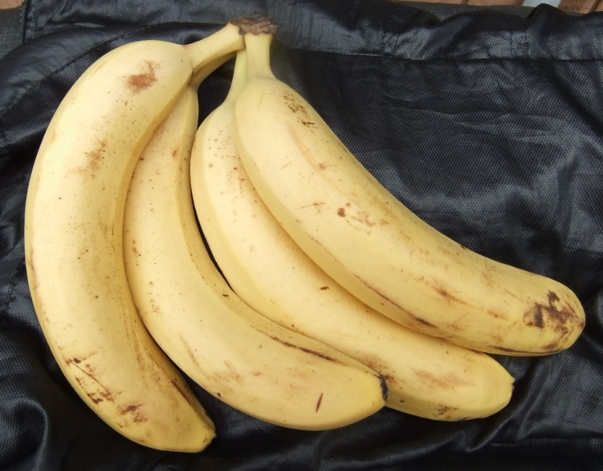 | bananas
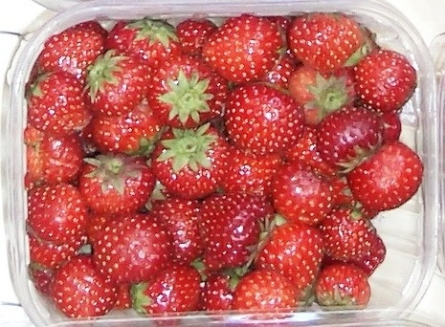 | strawberries
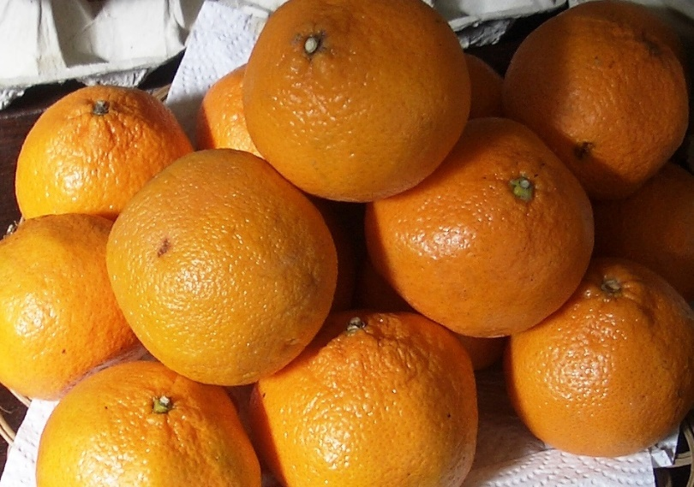 | oranges
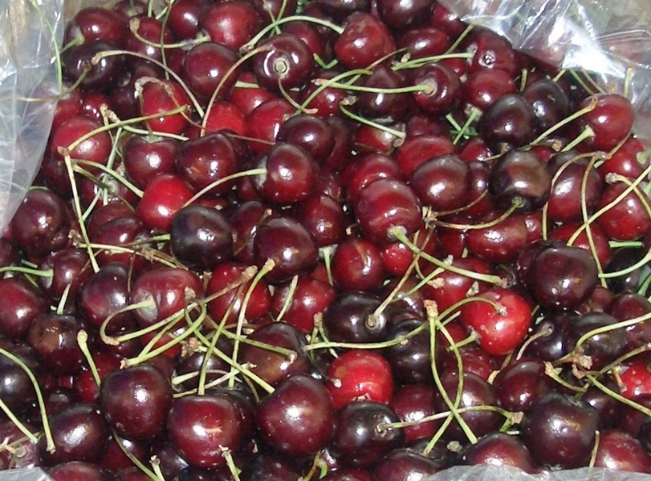 | cherries
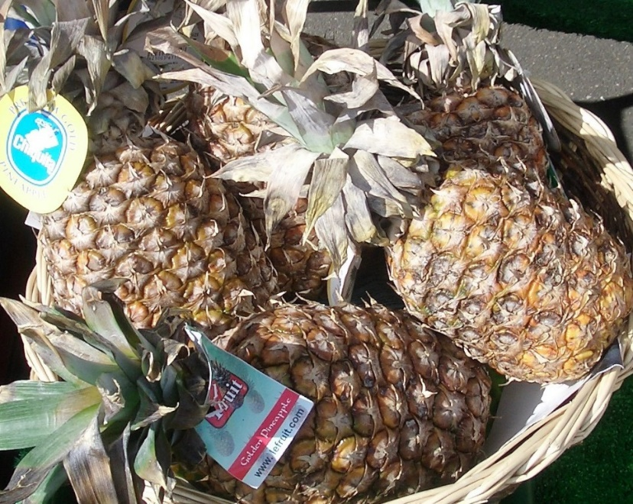 | pineapples
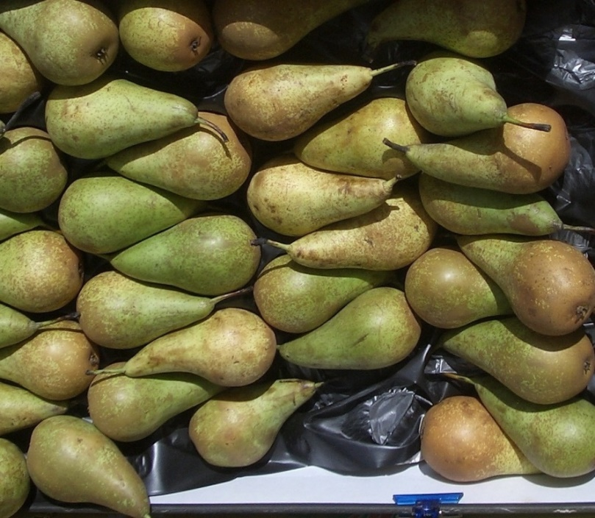 | pears
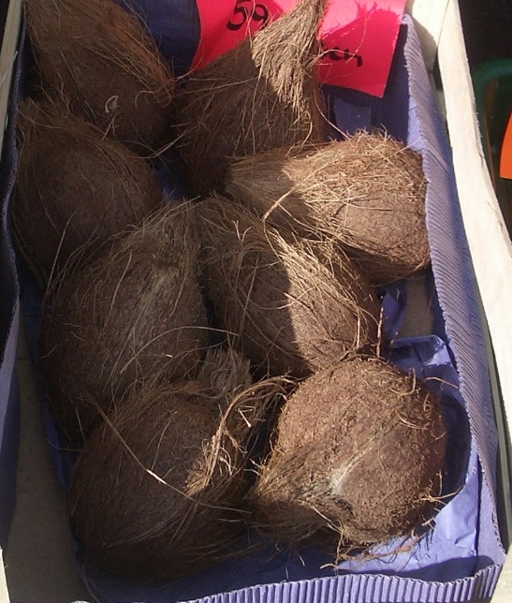 | coconuts
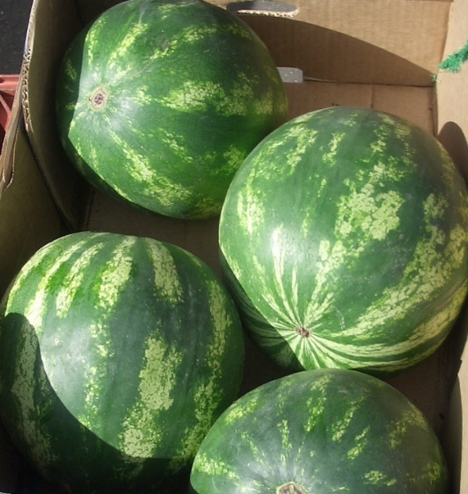 | watermelons
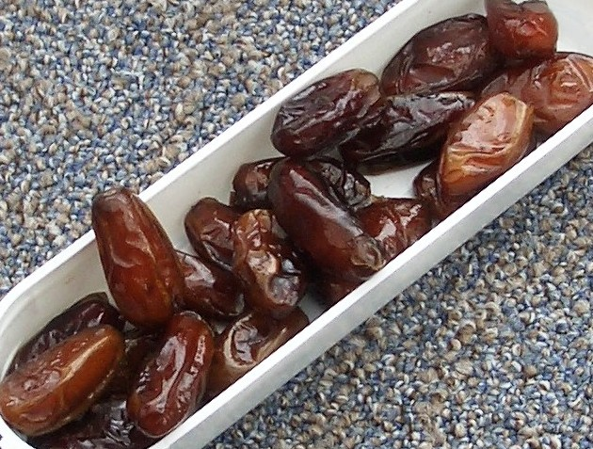 | dates
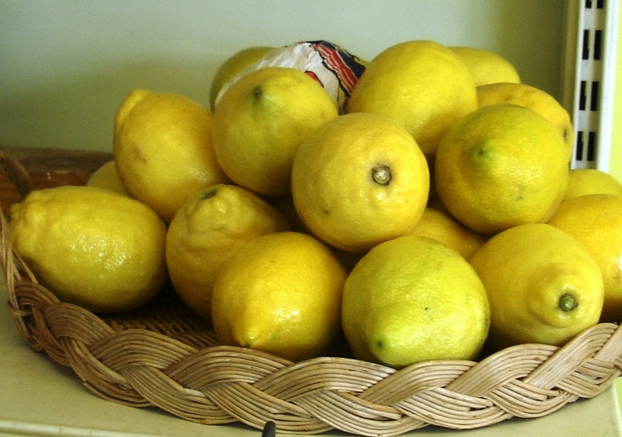 | lemons
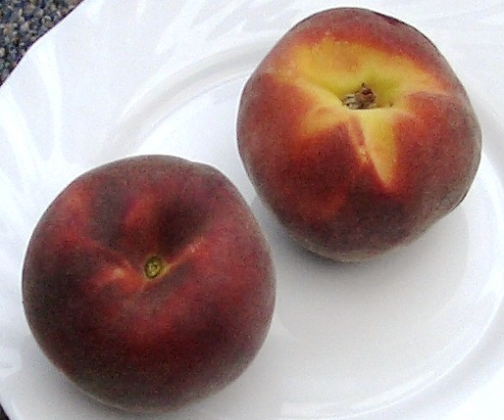 | peaches

Racing to English  Activity 5b |  | Fruit |  | Worksheet 1  copy work
o | oranges |  | oranges  ___________
l | lemons |  | lemons  ___________
d | dates |  | dates  ___________
c | 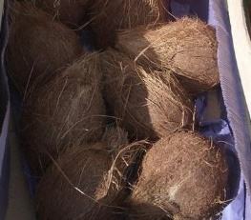  coconuts |  | coconuts  ___________
p | pineapples |  | pineapples  ___________
p | peaches |  | peaches  ___________

Racing to English  Activity 5b | Fruit | Worksheet 2

Draw the lines
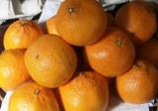
water cherries apples oranges pears
melons

Translate these words into your first language
English | First language: |  | English | First language:
apples |  |  | coconuts
oranges |  |  | pineapples
bananas |  |  | lemons

Now find these words in the wordsearch:
coconut  banana  cherries  apple  orange  pear  lemon  water  melon  dates | c | a | p | p | l | e | c
 | h | o | p | e | a | r | o
 | e | r | l | w | m | d | c
 | r | a | e | a | e | a | o
 | r | n | m | t | l | t | n
 | i | g | o | e | o | e | u
 | e | e | n | r | n | s | t
 | s | b | a | n | a | n | a

Racing to English  Activity 5b | Fruit | Worksheet 3

What colour are these fruits?
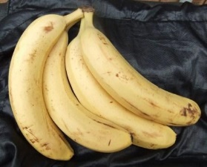

Ask your friend some questions.
Are these | bananas  lemons  strawberries  oranges  pears  dates  coconuts  watermelons  cherries | yellow?  red?  orange?  green?  brown? |  | Yes they are.  No they aren't.
Now write 10 questions and answer them.

Ask your friend some questions:
Do you like | oranges?  pears?  coconuts?  watermelons?  dates?  lemons?  bananas? |  | Yes I do.  No I don’t.  I don’t know.
Now write the questions and answer them.

Racing to English  Activity 5b | Fruit | Worksheet 4

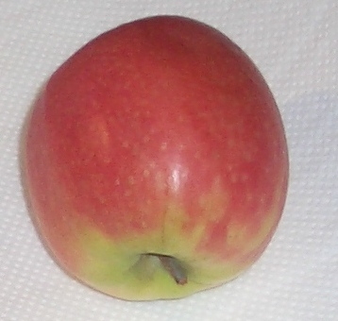 | 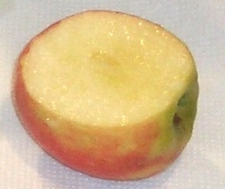
This apple is red on the outside. | Apples are white on the inside.

Read the sentences to your friend:
Bananas  Dates  Coconuts  Oranges  Pears  Pineapples  Strawberries  Watermelons | are | brown  green  orange  red  yellow | on the outside and | brown  orange  red  white  yellow | on the inside.
Now write the sentences.

