Racing to English  Activity 41b | Mobiles when driving | News

HEADLINE:
NEW RULE FOR MODBILE PHONE USE WHILST DRIVING

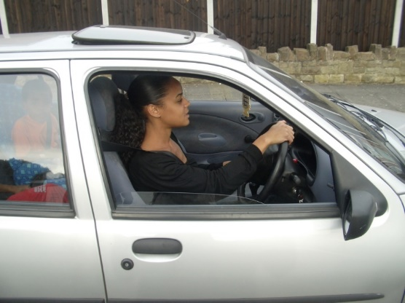 | Drivers all know that you're not allowed to use your mobile phone whilst you are driving. The Highway Code in Britain was updated in 2022, to clarify rule 149.  This rule says: "You MUST NOT use a hand-held mobile phone, or similar device for any purpose when driving or when supervising a learner driver.

This means that it is illegal for someone who is a driving instructor, to use their phone at all when in the car supervising a learner driver.
So, no texts or calls can be made, no photos or videos taken, no apps used and no browsing the internet.
The only exceptions to this new rule are the same as for the person who is driving:
- you can use your phone in an emergency to call 999 or 112 if it is unsafe or impractical to stop,
- you can use your phone if you are parked safely,
- and you can use your phone to park your vehicle remotely.
If you as the supervisor are found guilty of this rule you could be fined £200 and get six penalty points (NOTE in the UK if you get 12 penalty points you would lose your license).

Do some of these exercises. Work with a friend if possible.

- Translate the news story into your first language or another language.
- What other rules of the road do you know? Write 10 of them.
- After reading the story who do you think is right that using a mobile phone whilst driving is banned?
- Write definitions for these words:
highway code | device | purpose | guilty
supervising | learner | illegal | instructor
browsing | exception | emergency | impractical

Are there any other words you find difficult?

