Racing to English  Activity 30c | Emily Davison | True stories

Emily Davison died in 1913. She died after a horse race.  The horse race was called the Derby. Many people were watching the race. The king was there. He owned one of the horses and he was watching the race. He wanted his horse to win.  Emily ran on to the course and tried to stop one of the horses. It was the horse that was owned by the king. |  | 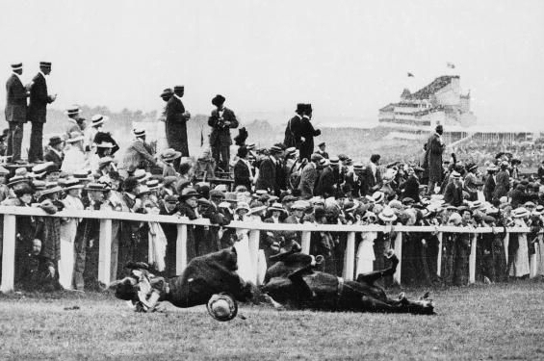
The horse fell; it seriously injured Emily and she died four days later. It also injured the rider but he recovered. Why did Emily try to hold on to the horse? Emily was a suffragette. Suffragettes wanted women to be allowed to vote in elections for parliament.
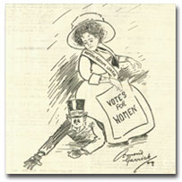 | At that time women could not vote; only men could vote. Suffragettes did many things to protest and persuade people to give women the vote.  Some women tied themselves to railings; some broke windows; some burnt post-boxes; some even set off bombs. Many women were arrested and sent to prison.  Emily tried to stop the king’s horse. It was her way of making a protest.  In 1914 the first world war started and millions of men went to fight. During the war women did the work of men. Men saw that women could do many things. In 1918, at the end of the war, women were given the vote.

Ask your friend these questions:
- What did the suffragettes want?  - When did Emily die?  - What did Emily want to stop?  - What did the horse do? | - What started in 1914?  - When were women given the vote?  - Do you know of another time when someone made a protest? What happened?

Now write the answers to the questions yourself.

Racing to English  Activity 30c | Emily Davison | Worksheet

Look at this passage with some friends. Decide which words fit in each space:
Emily Davison died in 1913 after a horse race. Many people _________ 1 _________ the race. The king was there. He owned one of the horses and he __________ 2 __________ the race. He wanted his horse to win.
Emily ran on to the course and __________ 3 __________ one of the horses. It was the horse that was owned by the king. The horse fell; it __________ 4 __________ Emily and she died four days later. It __________ 5 __________ the rider but he recovered.
Why did Emily try to hold on to the horse? Emily was a suffragette. Suffragettes wanted women __________ 6 __________ vote in elections for parliament. At that time women __________ 7 __________ vote; only men could vote. Suffragettes did many things to __________ 8 __________ and persuade people to give women the vote. Some women tied themselves to railings; some broke windows; some burnt post boxes; some even set off bombs. Many women __________ 9 __________ and sent to prison. Emily tried to stop the king’s horse. It was her way of __________ 10 __________ .
In 1914 the First World War started and millions of men __________ 11 __________. During the war women did the work of men. Men saw that women could do many things. In 1918, at the end of the war, women __________ 12 __________ the vote.
also injured  making a protest  protest  seriously injured | to be allowed to  tried to stop  was watching  went to fight | were arrested  were given  could not  were watching

