Racing to English  Activity 8a | Vehicles | Picture  Dictionary

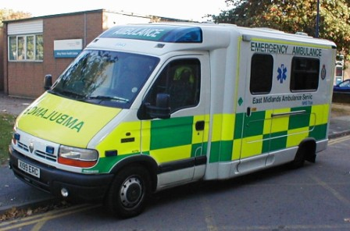  an ambulance  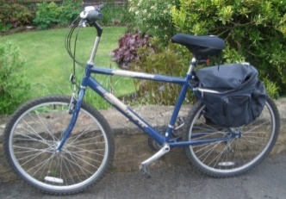  a bike  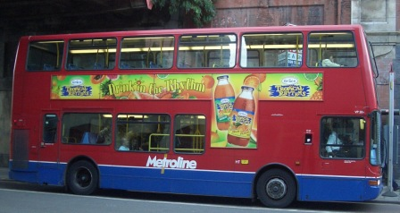  a bus  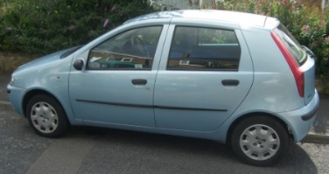  a car  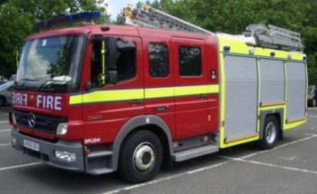  a fire engine | 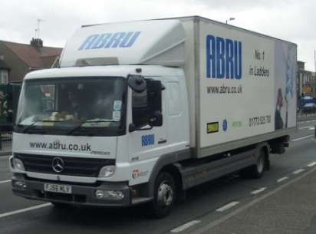  a lorry  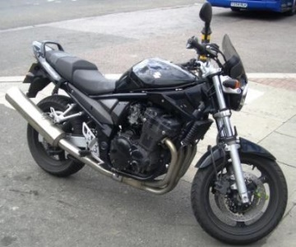  a motorbike  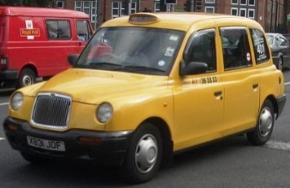  a taxi  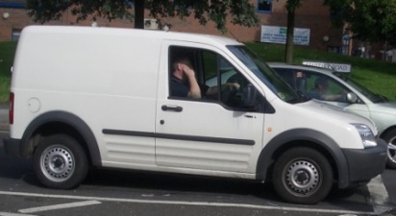  a van

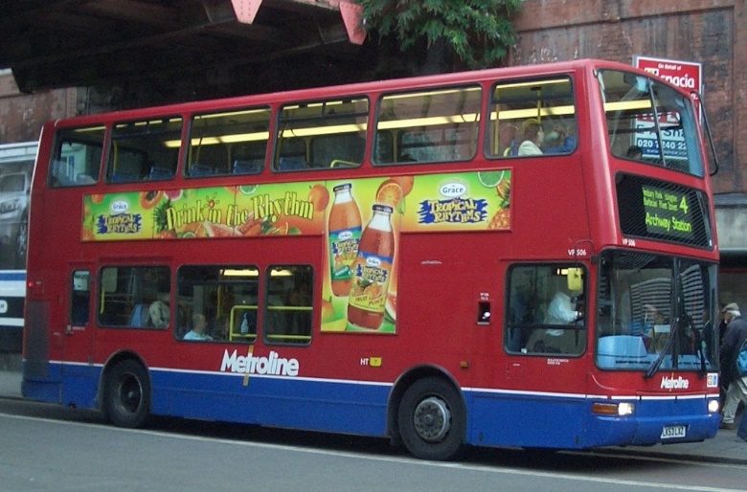 | a bus
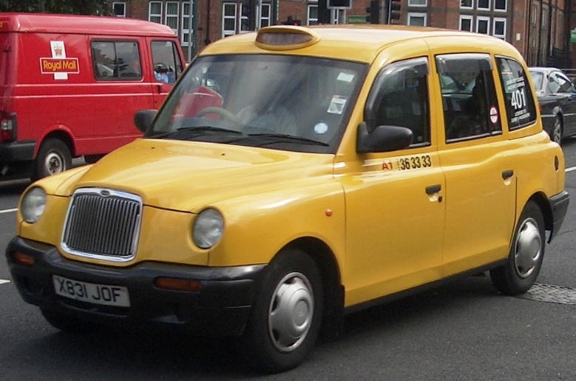 | a taxi
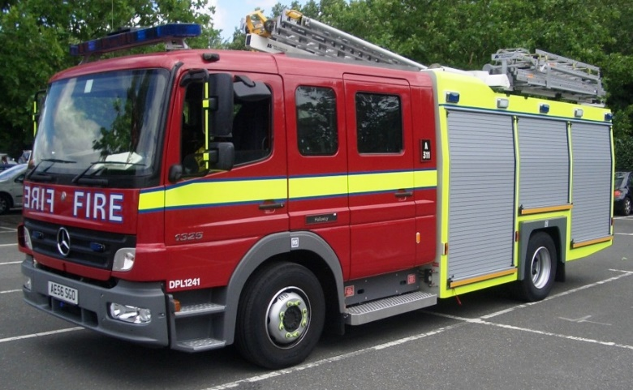 | a fire engine
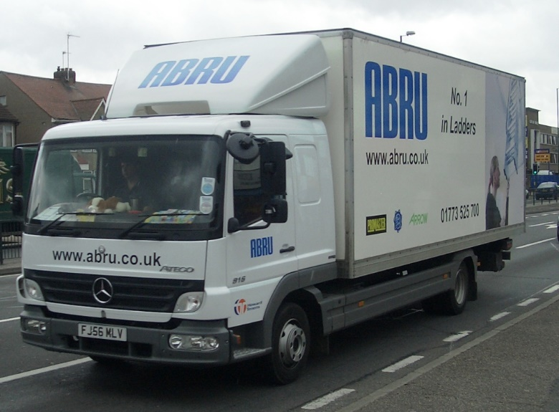 | a lorry
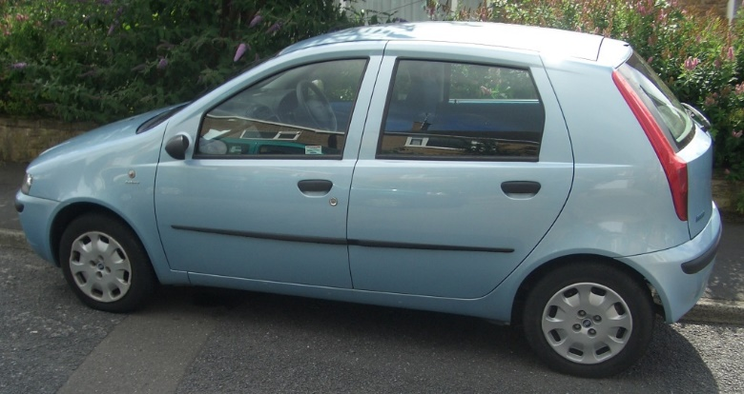 | a car
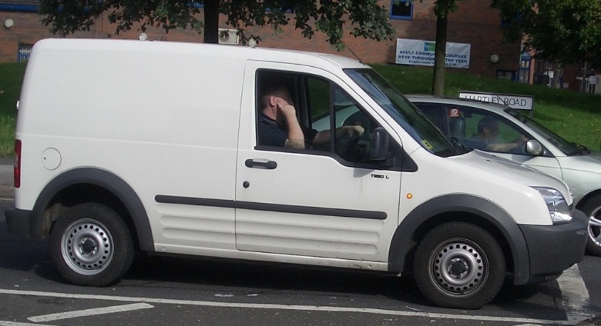 | a van
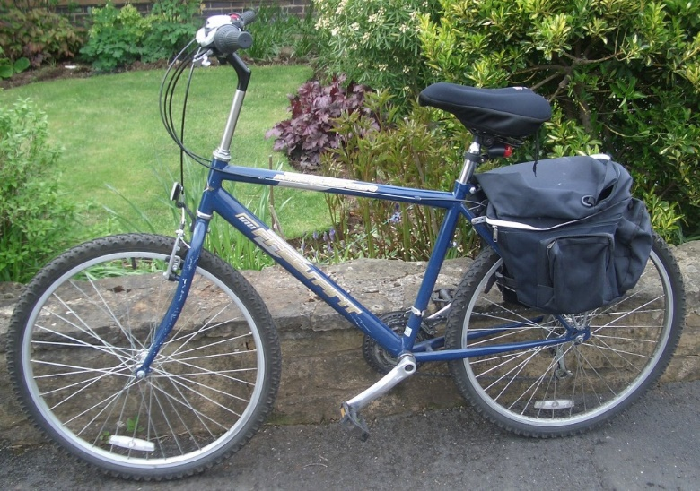 | a bike
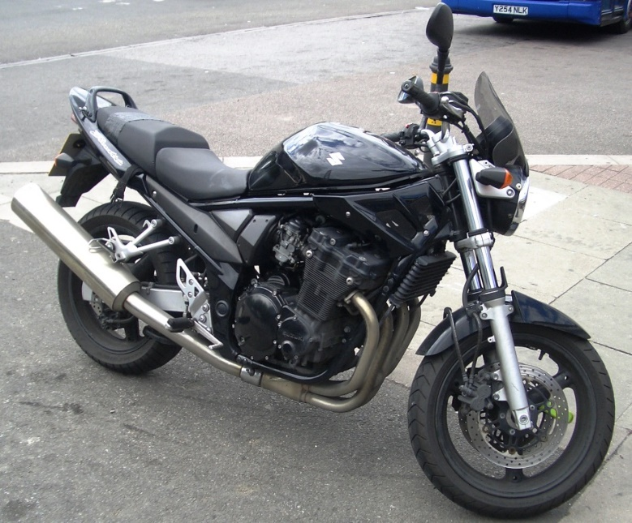 | a motorbike
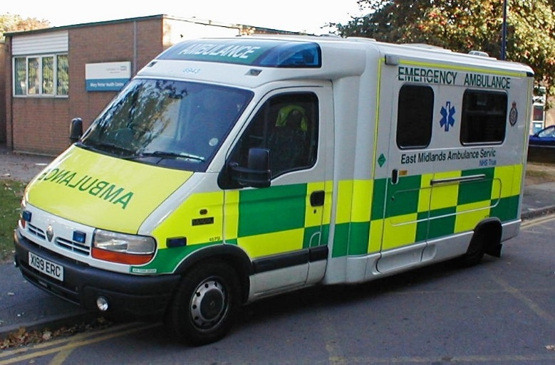 | an ambulance

Racing to English  Activity 8a | Vehicles | Worksheet  1

Draw the lines
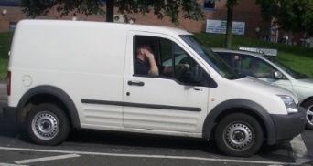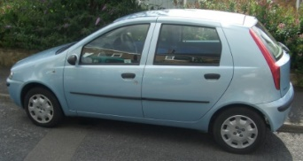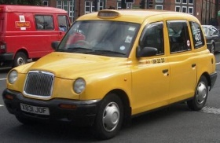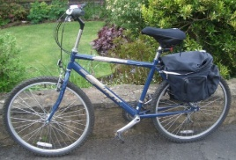
car bike van taxi

Translate these words into your first language
English | First language: |  | English | First language:
car |  |  | bike
lorry |  |  | motorbike
bus |  |  | ambulance

Now find these words in the wordsearch:

ambulance  wheel is  car bus  bike motorbike  yellow taxi  white blue  fire engine  lorry van  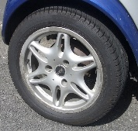 | w | h | i | t | e | b | l | u | e
 | m | o | t | o | r | b | i | k | e
 | l | y | e | l | l | o | w | b | w
 | o | f | b | t | a | x | i | i | h
 | r | i | u | v | a | n | i | k | e
 | r | r | s | c | a | r | s | e | e
 | y | e | e | n | g | i | n | e | l
 | a | m | b | u | l | a | n | c | e

Racing to English  Activity 8a | Vehicles | Worksheet 2
Ask your friend some questions:
Has | an ambulance  a bus  a bike  a car  a taxi  a lorry  a fire engine  a van  a motorbike | got | 2  4  6  8 | wheels? |  | Yes it has.  No it hasn’t.
Now write 10 questions and answer them.

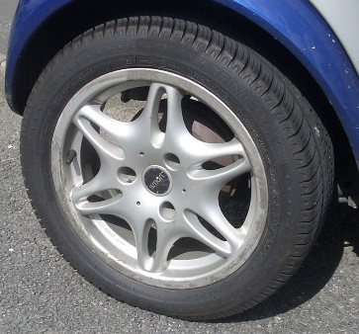  a wheel | 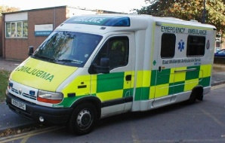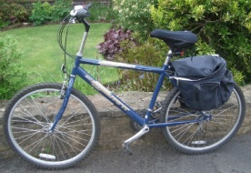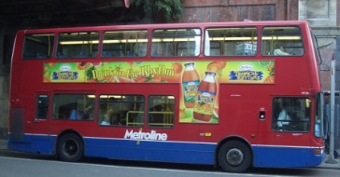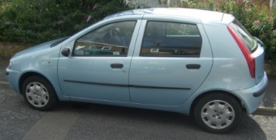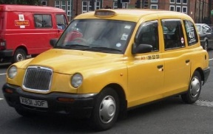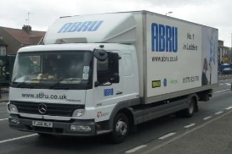  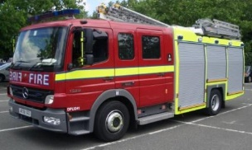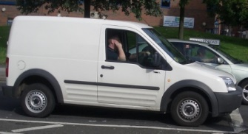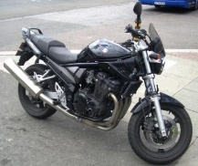

Now ask your friend some more questions:
Is | the ambulance  the bus  the bike  the car  the taxi  the lorry  the fire engine  the van  the motorbike | white?  red?  yellow?  black?  blue? |  | Yes it is.  No it isn’t.
Now write 10 questions and answer them.

